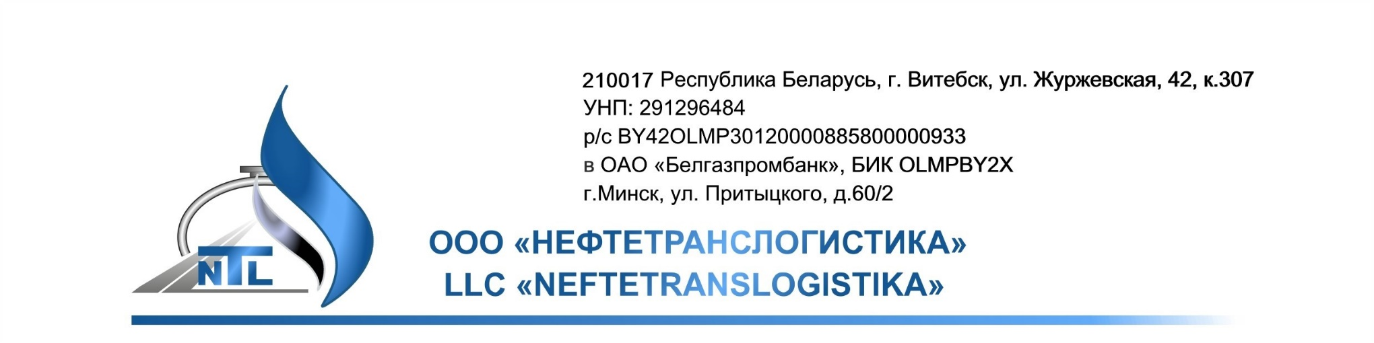
Partner card

1 | Organizational and legal form | Limited liability company
2 | Full name of the company | Neftetranslogistika Limited Liability Company
3 | Brief name of the company | Neftetranslogistika LLC
4 | Payer's Identification Number (UNP)/OKPO | 291296484/304743331000
5 | Registered office | 210017, Vitebsk, Zhurzhevskaya str., Bld. 42, Office No. 307
6 | Mailing address | 220062, Minsk, P. O. box 46
7 | Telephone/Fax number | 8-017-270-18-32, 8-017-270-18-31
8 | Number and date of incorporation in the Unified State Register of Legal Entities and Individual Entrepreneurs | 291296484 dated 16/07/2015
9 | Bank name, bank code | Belgazprombank JSC, BIC OLMPBY2X
10 | Bank address | 220121, Minsk, Pritytskogo str., Bld. 60/2
11 | Current account (Belarusian rubles) | BY42OLMP30120000885800000933 (BYN)
12 | Current account (USD) | BY31OLMP30120000885800000840 (USD)
13 | Current account (Russian rubles) | BY150LMP30120000885800000643 (RUB)
14 | Current account (EUR) | BY88OLMP3012000088580000978 (EUR)
15 | Correspondent account for settlements in RUB  Correspondent bank:  Beneficiary bank: | Bank GPB (JSC), Moscow  correspondent account at the General Directorate of the Bank of Russia for the Central Federal District No. 30101810200000000823, BIC 044525823  Taxpayer Identification Number (INN) 7744001497, SWIFT code: GAZPRUMM  No. 30111810900000026155  Belgazprombank JSC, Minsk  SWIFT code: OLMPBY2X
16 | Correspondent account for settlements in USD  Correspondent bank:  Beneficiary bank: | Raiffeisen Bank International AG, Vienna  SWIFT code: RZBAATWW  acc.: 070-55.058.887  BELGAZPROMBANK JSC, BELARUS,  SWIFT code: OLMPBY2X
17 | Correspondent account for settlements in EUR  Correspondent bank:  Beneficiary bank: | Raiffeisen Bank International AG, Vienna  SWIFT code: RZBAATWW  acc.: 000-55.058.887  BELGAZPROMBANK JSC, BELARUS,  SWIFT code: OLMPBY2X
18 | Bank name, bank code | Priorbank JSC, BIC PJCBBY2X
19 | Bank address | Minsk, Horuzhei str., Bld. 31A
20 | Current account (Belarusian rubles) | BY70PJCB30120628911000000933 (BYN)
21 | Current account (USD) | BY59PJCB30120628911000000840 (USD)
22 | Current account (Russian rubles) | BY43PJCB30120628911000000643 (RUB)
23 | Current account (EUR) | BY19PJCB30120628911000000978 (EUR)
24 | Correspondent account for settlements in RUB  Correspondent bank:  Beneficiary bank: | Sberbank of Russia, Moscow  Taxpayer Identification Number (INN) 7707083893; BIC 044525225  No. 30101810400000000225 at OPERU of Moscow Central Territorial Administration of Bank of Russia  No. 30111810200000000136  at Directorate of Belinvestbank JSC for Minsk and Minsk Region  BIC BLBBBY2X
25 | Correspondent account for settlements in USD  Correspondent bank:  Beneficiary bank: | CITIBANK NA, New York, USA,SWIFT: CITI US 33  acc. 36089449  «Priorbank» JSC, branch 115, Minsk, Belarus  SWIFT code: PJCBBY2X
26 | Correspondent account for settlements in EUR  Correspondent bank:  Beneficiary bank: | RAIFFEISEN BANK INTERNATIONAL, AG, Vienna, Austria, SWIFT: RZBAATWW  acc. 55.045.512  «Priorbank» JSC, branch 115, Minsk, Belarus  SWIFT code: PJCBBY2X
27 | Head of the company | Acting Director of Neftetranslogistika LLC Kravtsov Dmitry Alexandrovich, acting on the basis of Order No. 3 of 26 January 2026
28 | Chief Accountant of the company | Chief Accountant of Neftetranslogistika LLC Makrenkova Mariya Vasilyevna
29 | Seal imprint | L.S.

